Good evening. We are Nayan on trumpet, Jamaal on harp, Adrian on cello and I am, Danya, on viola, from the Chineke! Junior Orchestra.

We are really looking forward to sharing our piece, which is inspired by the story of **Dido Belle.**

Dido Belle was born in the West Indies and was the illegitimate daughter of an African slave called **Maria Belle** and **John Lindsay**, who was an officer in the navy.

She was brought here to Kenwood by her father when she was 5 years old to live with her great uncle, **Lord Mansfield** and his wife.

Very unusually for a Black person at the time, she was brought up as an aristocrat and taught to read and write and play music.

As England’s most powerful judge, Lord Mansfield and his judgments to limit the rights of slave owners helped the abolition of slavery movement and it is our privilege to be here tonight.

We know that Lord Mansfield trusted Dido to help with his paperwork and she was treated as part of the family. She would have faced a lot of racism from society. Lord Mansfield left her money in his will and she became a wealthy heiress.

We can see that Dido Belle was loved by Lord Mansfield. as he made sure that she featured in the portrait with her cousin, Lady Elizabeth Murray.

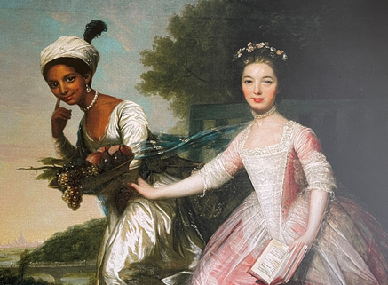

At the time, most of the pictures of Black people showed them as slaves.

Dido Belle’s story is a remarkable one and we are pleased that it will be heard.

Nayan will now talk you through our composition.

Thank you Danya. We all took a lead in composing a section of this piece imagining a point in Dido’s life, including Kitan who can’t be here as she has a GCSE exam tomorrow. Jamaal then brought our separate sections together, and added the little but important flourishes linking the parts.

Our composition starts with Dido’s life in the Caribbean; represented by a West Indian rhythm. We follow her long voyage across the sea to this amazing mansion, Kenwood House. We hear a sea shanty with the main melody played by the viola and trumpet; this leads into softer phrase of calm water. But we then hear a troubled phase as the ship sails through stormy waters. This also represents the internal anxiety we imagine Dido felt leaving her mother and homeland to go to the strange and unknown.

After, you hear an arrangement of the 1st movement of Joseph Boulogne's 1st Symphony in G; symbolising her life at Kenwood House. We chose this piece both because it was composed in Dido Belle’s lifetime and also as Joseph Boulogne was mixed race. Our orchestra is about creating opportunities for emerging and established musicians of Black and ethnically diverse heritage. The piece finishes with a fanfare celebrating her incredibly interesting, inspirational and intriguing life.

We’d like to thank English Heritage and Shout Out Loud for this amazing initiative.